**Name -Monika Gariya**

**Email-** [**monikagariya2023@gmail.com**](mailto:monikagariya2023@gmail.com)

**Data Engineering Batch 1**

**Date – 29-01-2024**

**Topic – Introduction to Python, Control, Structure, Functions, OOPs, Modules**

**Introduction to python**

**1)Datatypes**

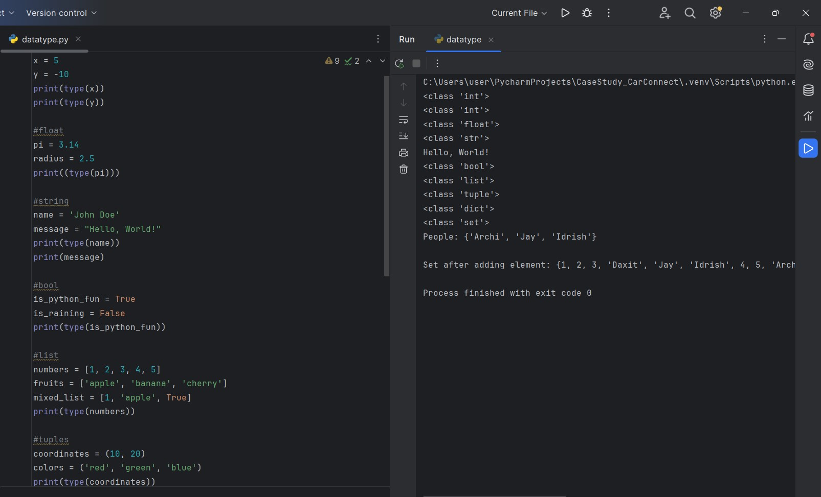

**2)Identifier**

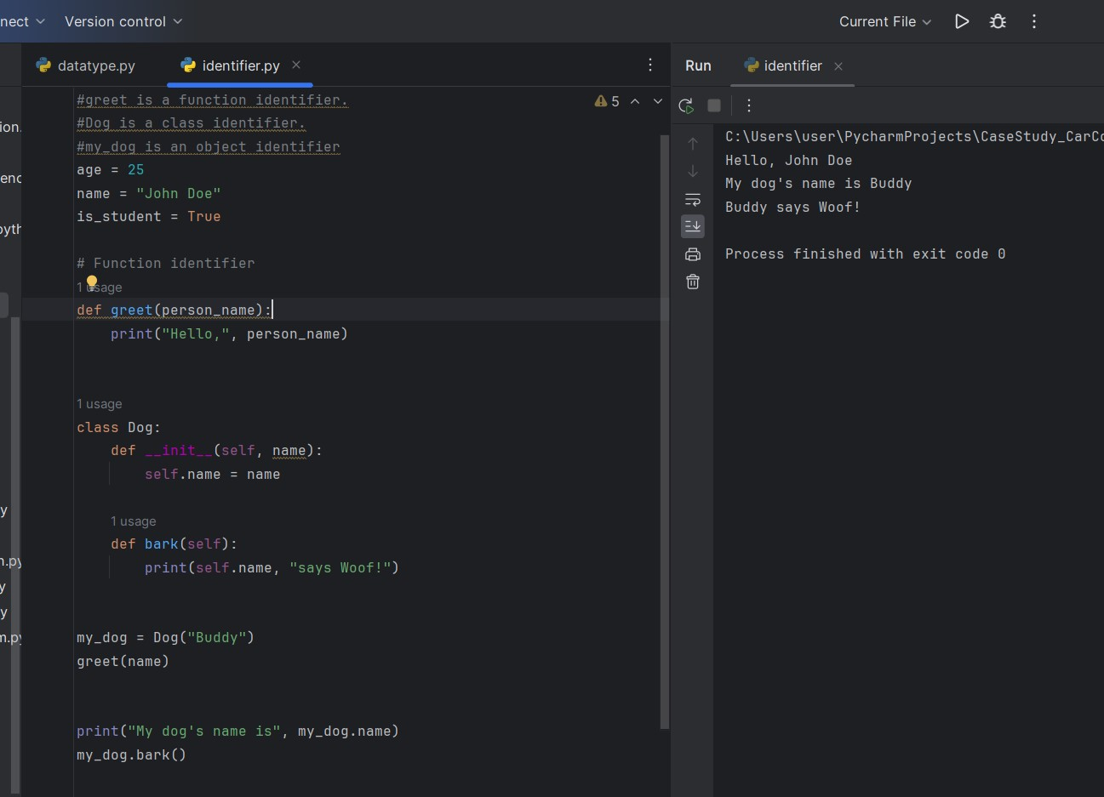

**3)Keyword**

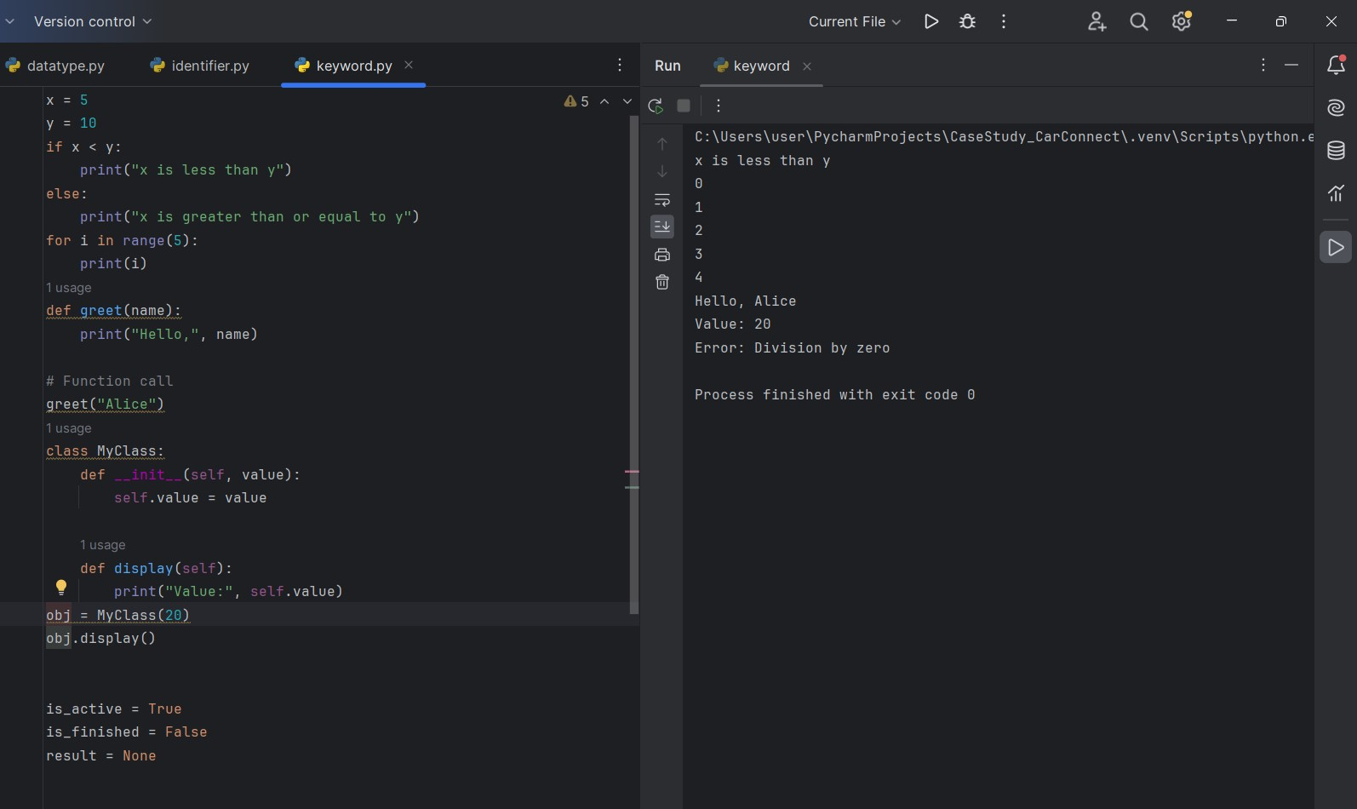

**4)Variable**

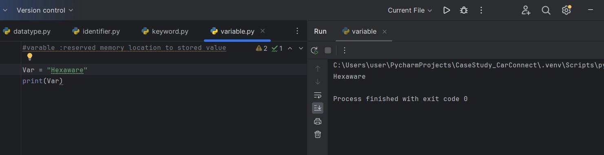

**2)Control statement**

**1)loops -if, else, while, for, nested loop**

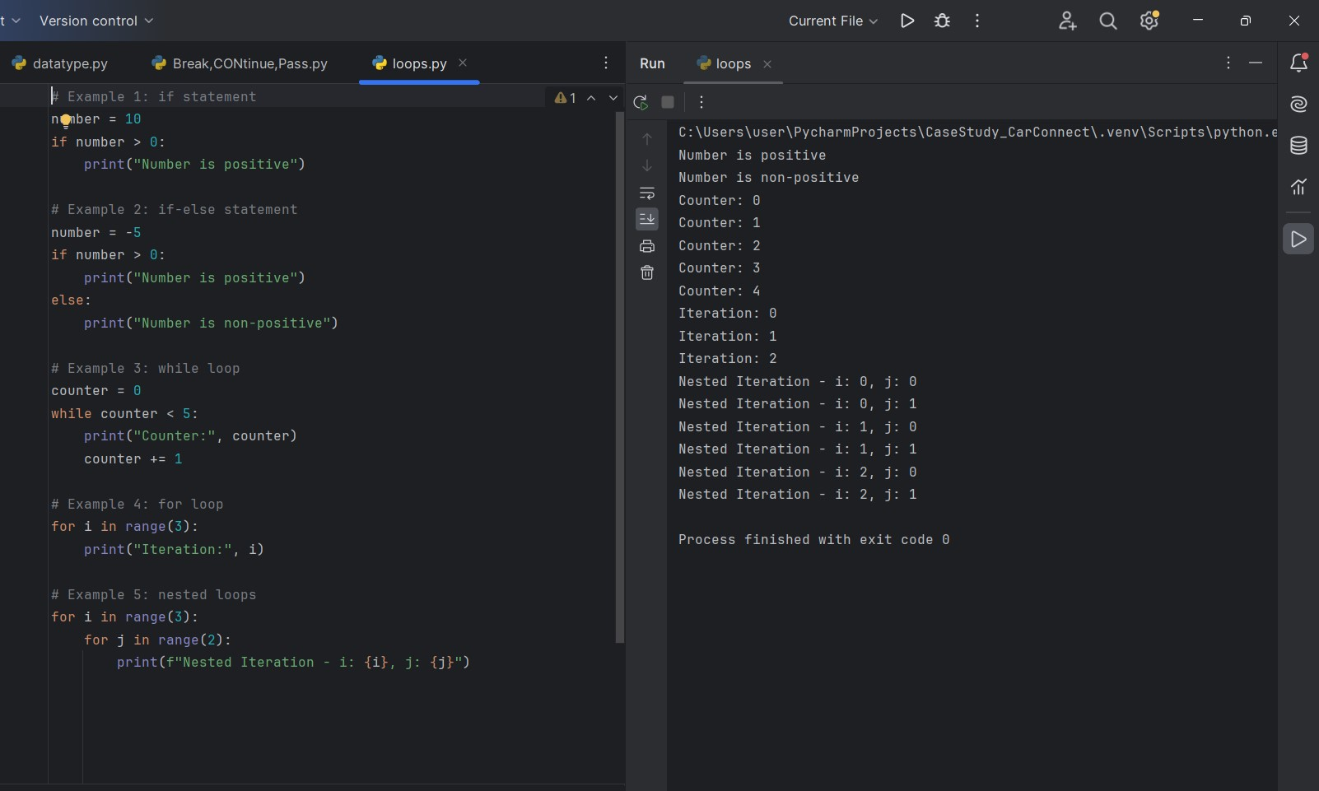

**2)Break, continue and pass**

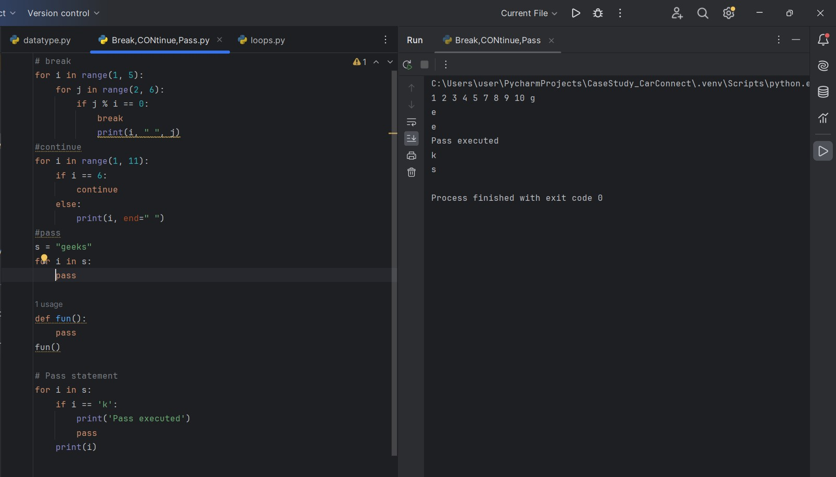

**3)List and List methods**

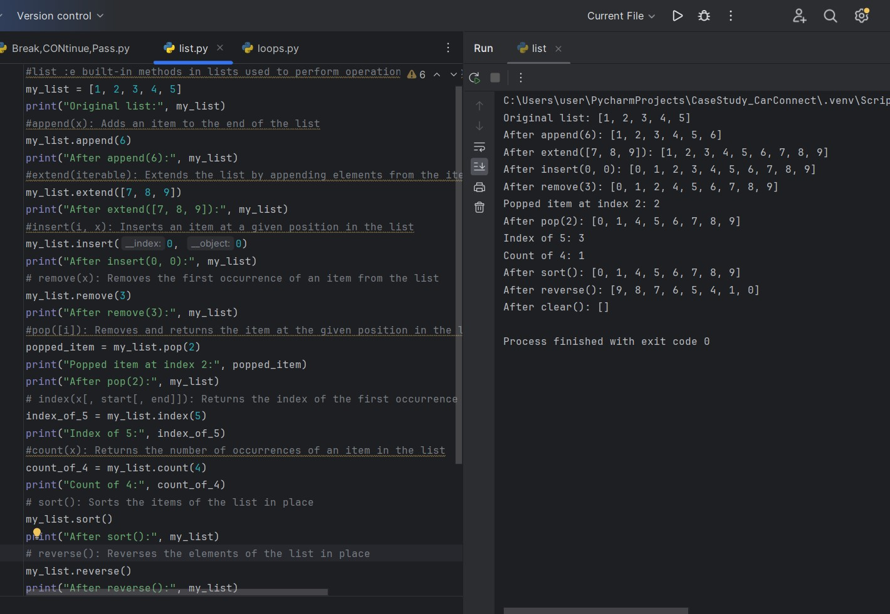

**4)Dictionary And dict Methods**

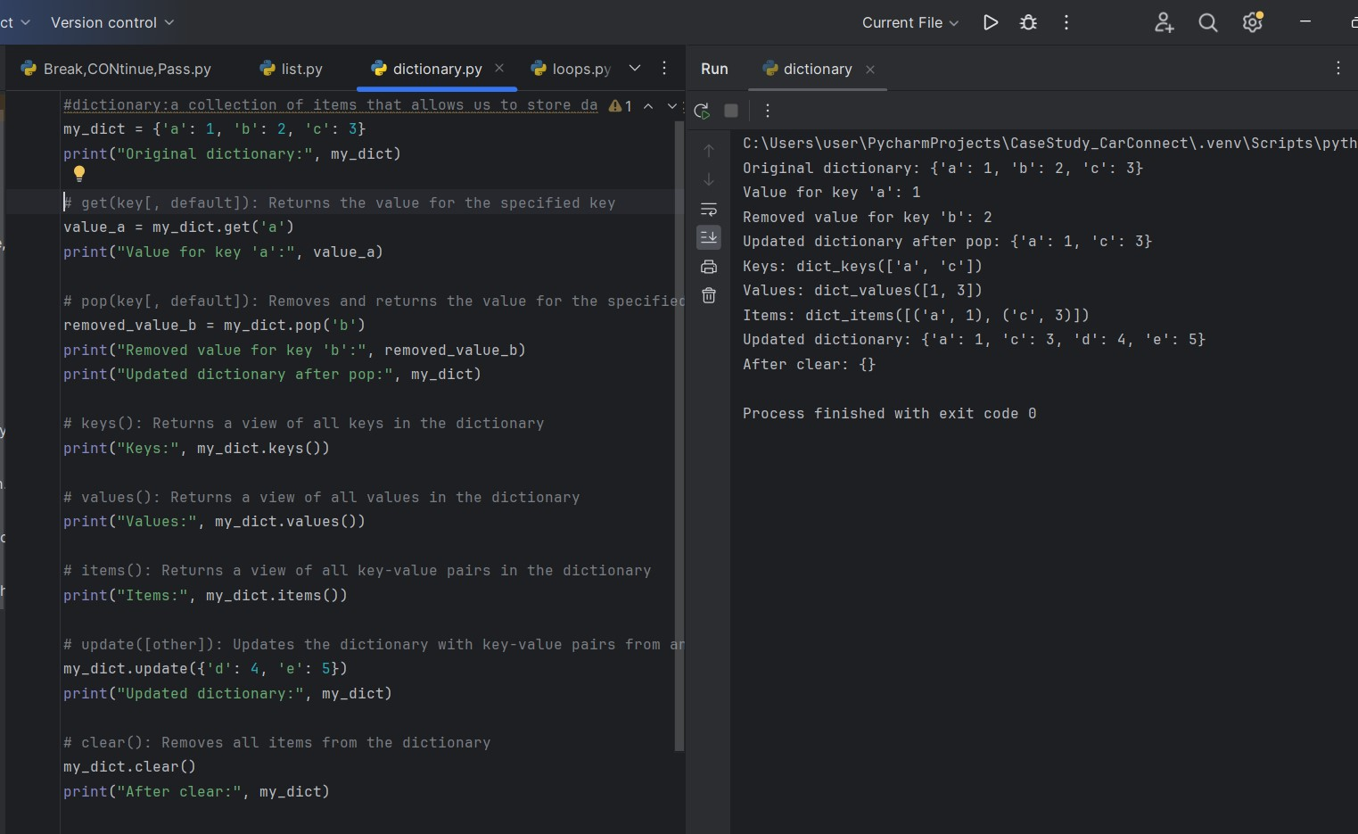

**5)Set and set methods**

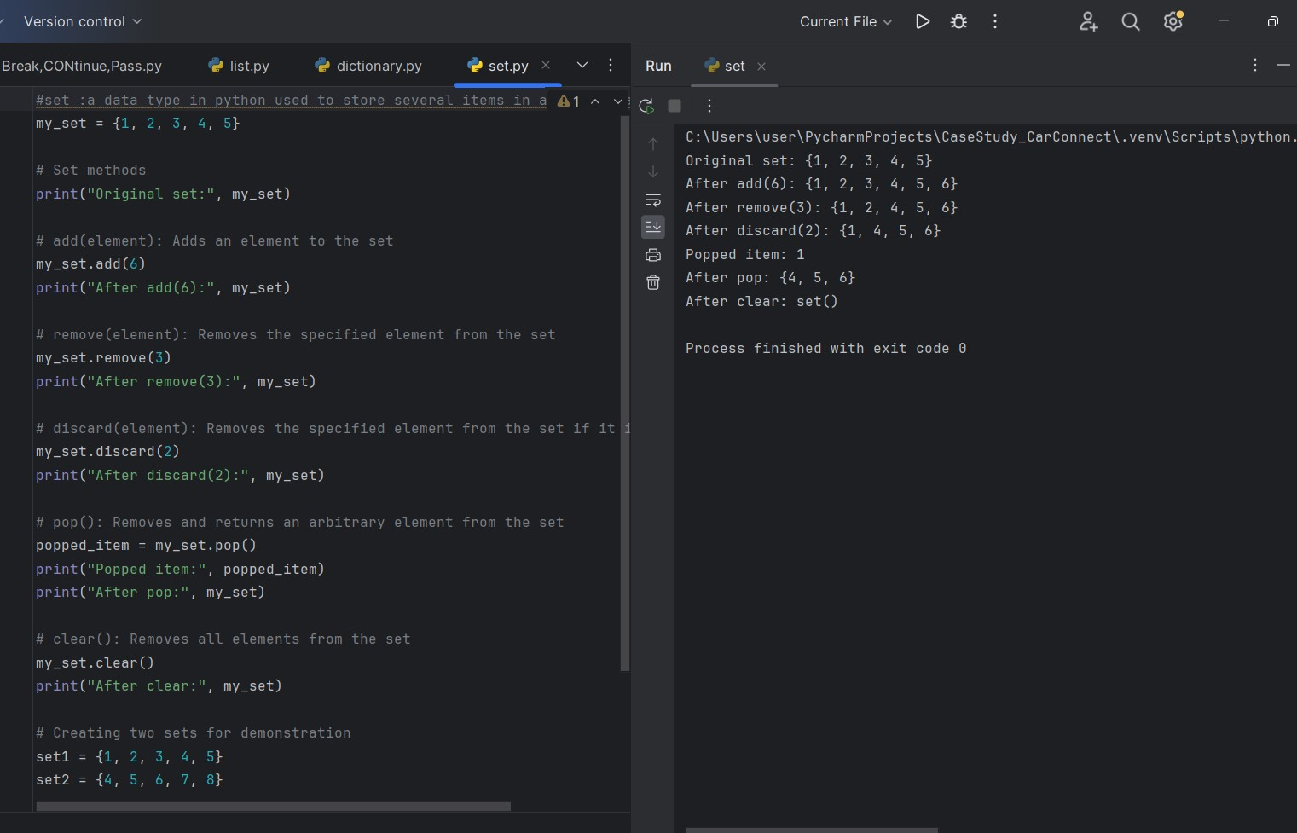

**3)Functions**

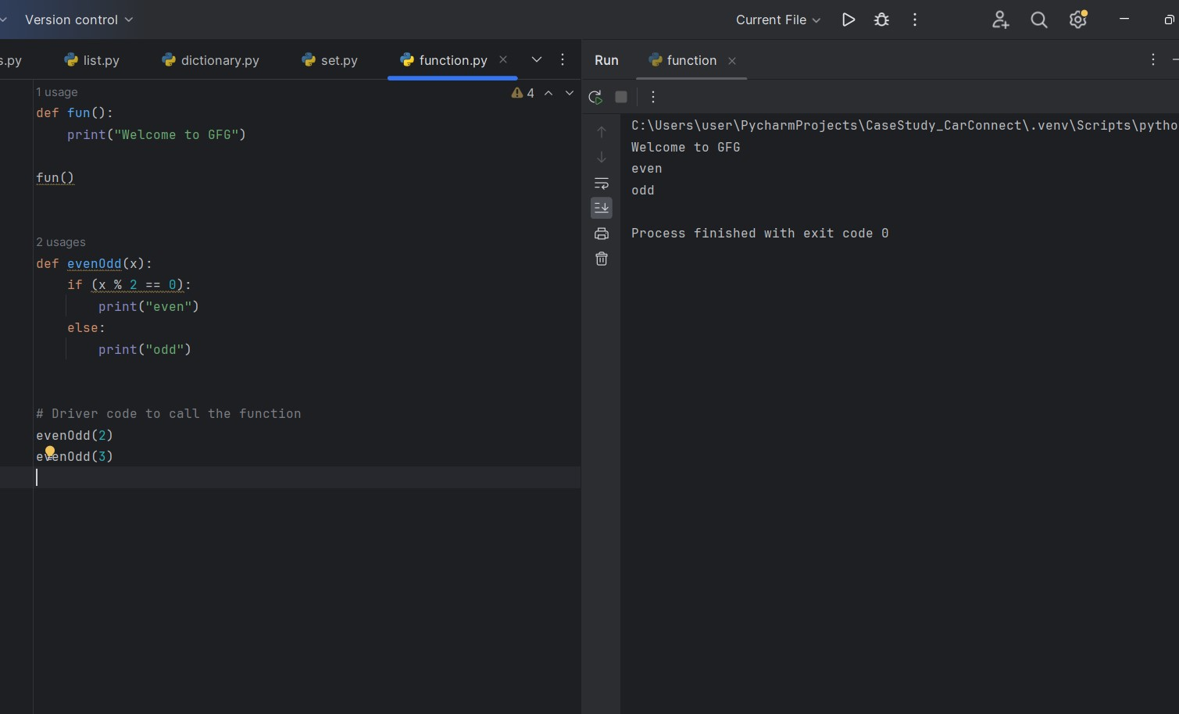

**2)Mapping**

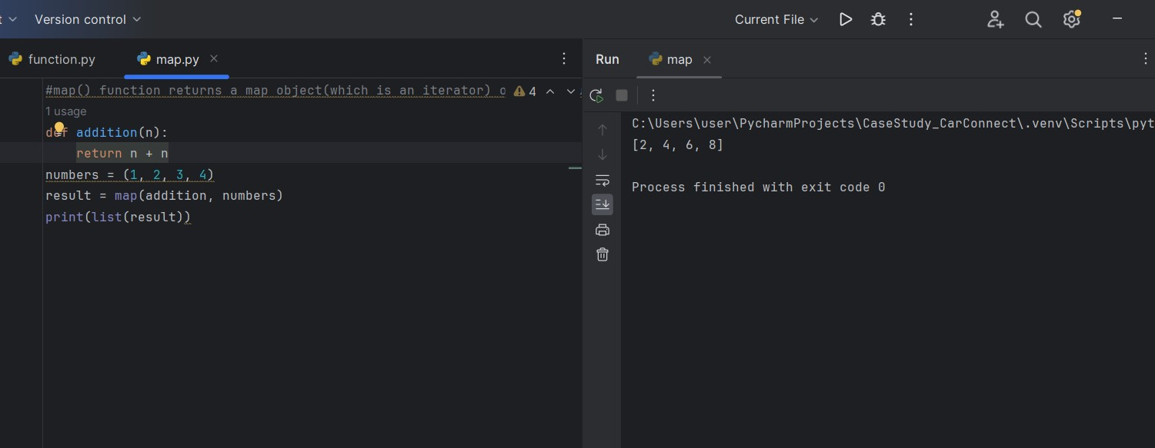

**3)String**

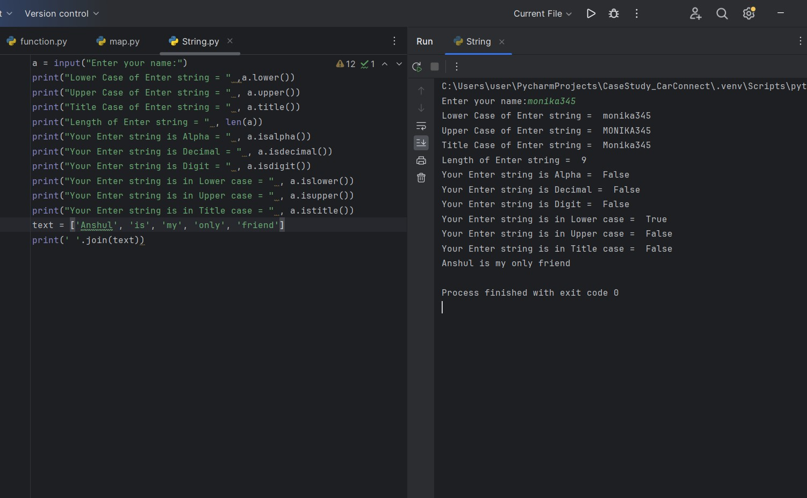

**4)Date and Time function**

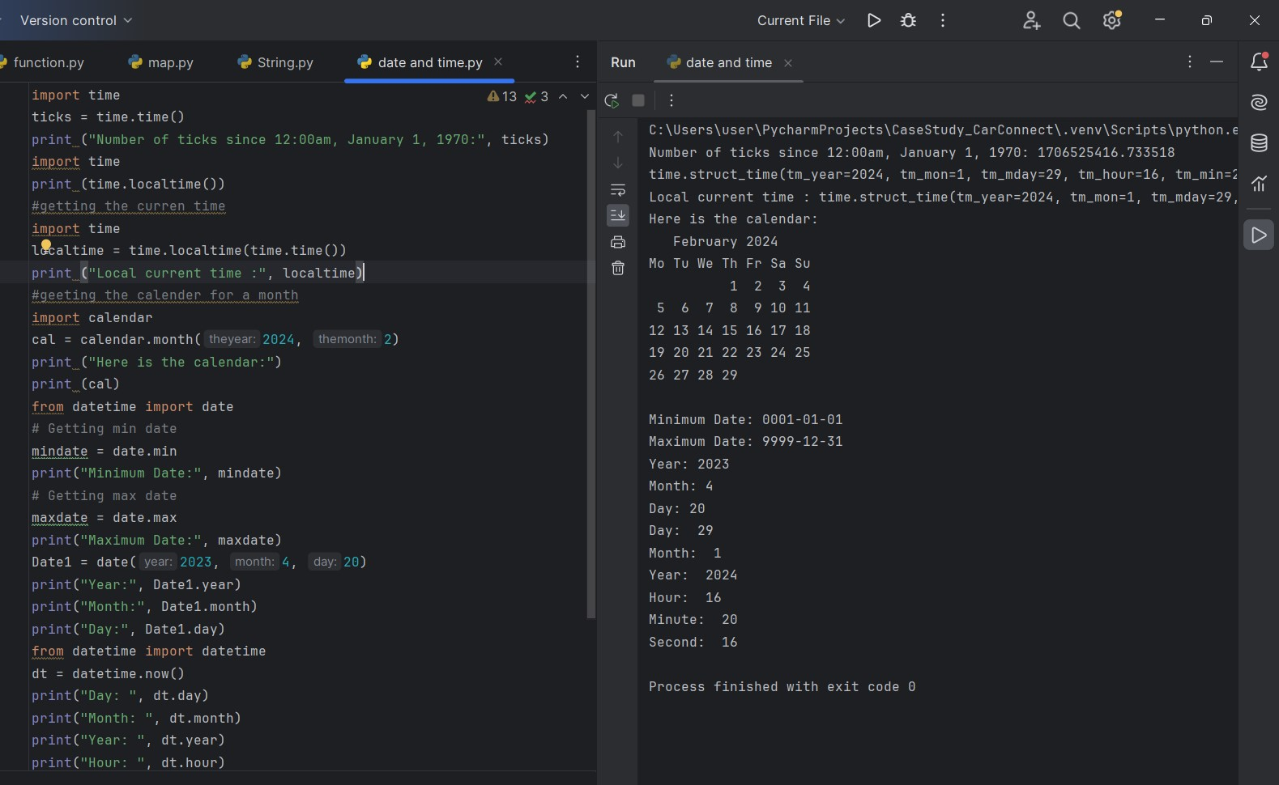

**5) Lambda function**

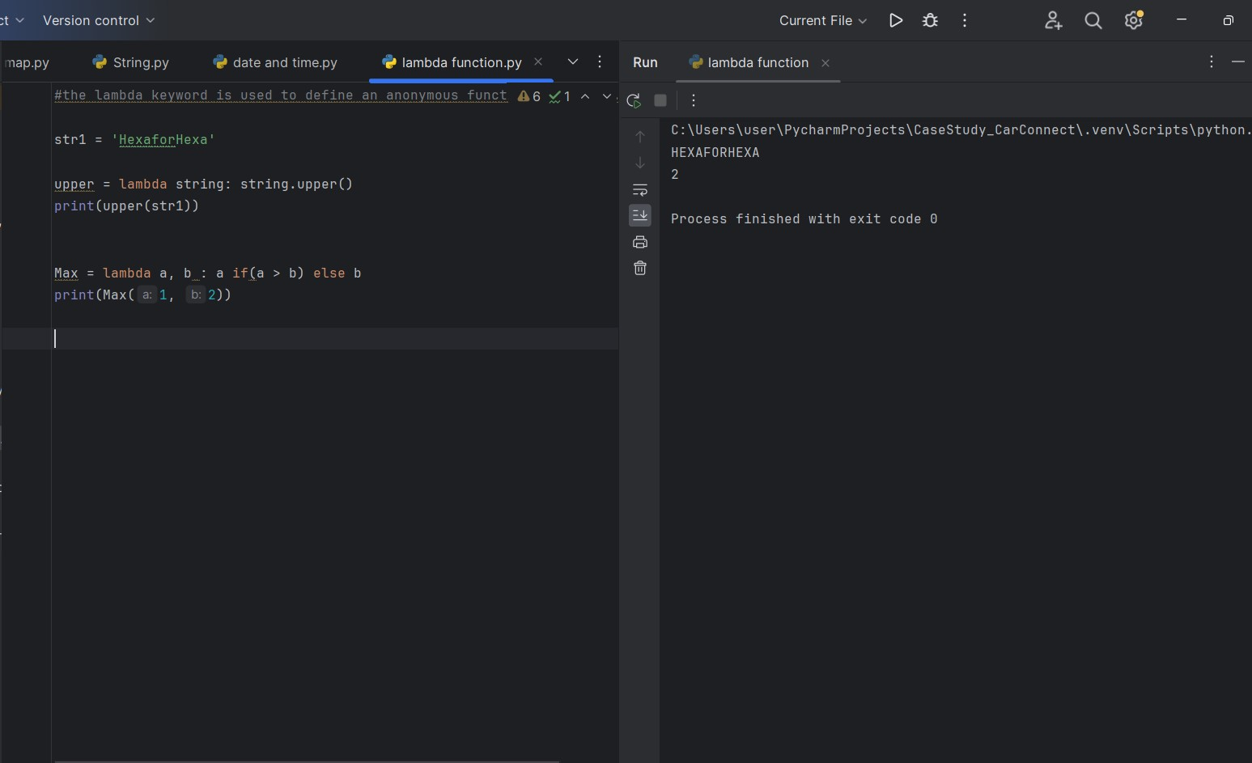

**4)OOPs**

**1) Classes and Object**

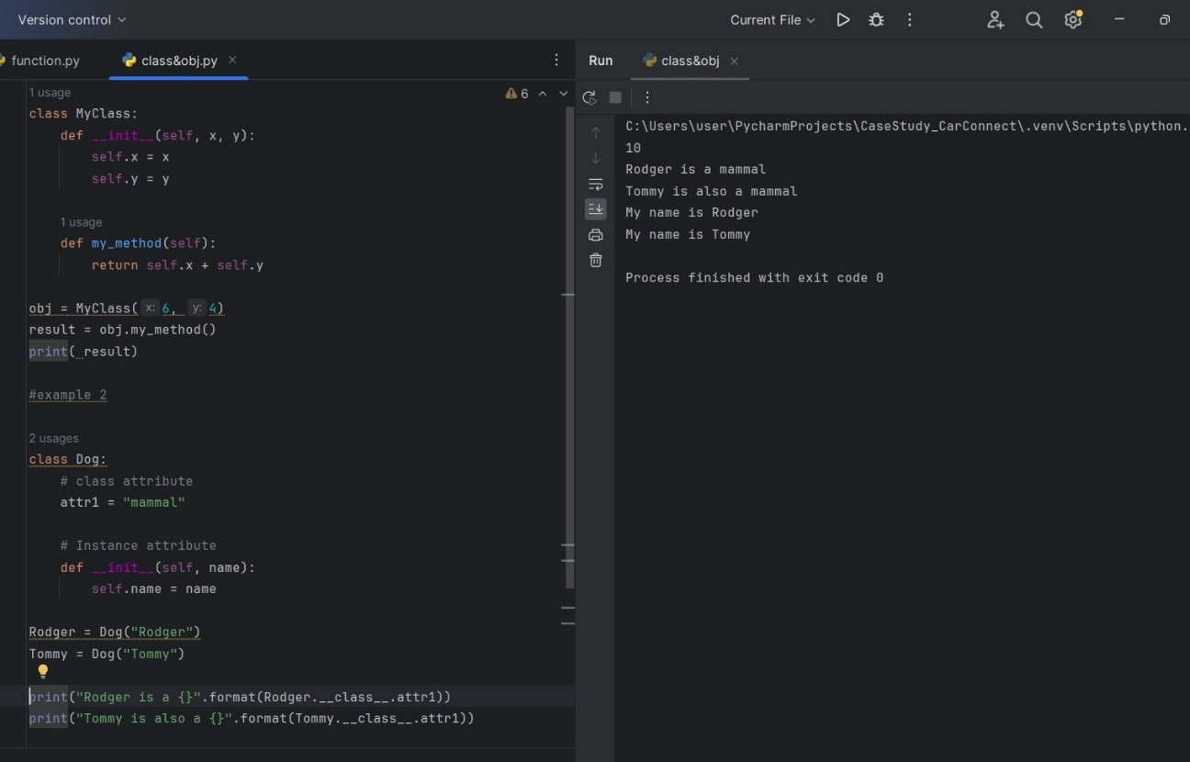

**2)Abstraction**

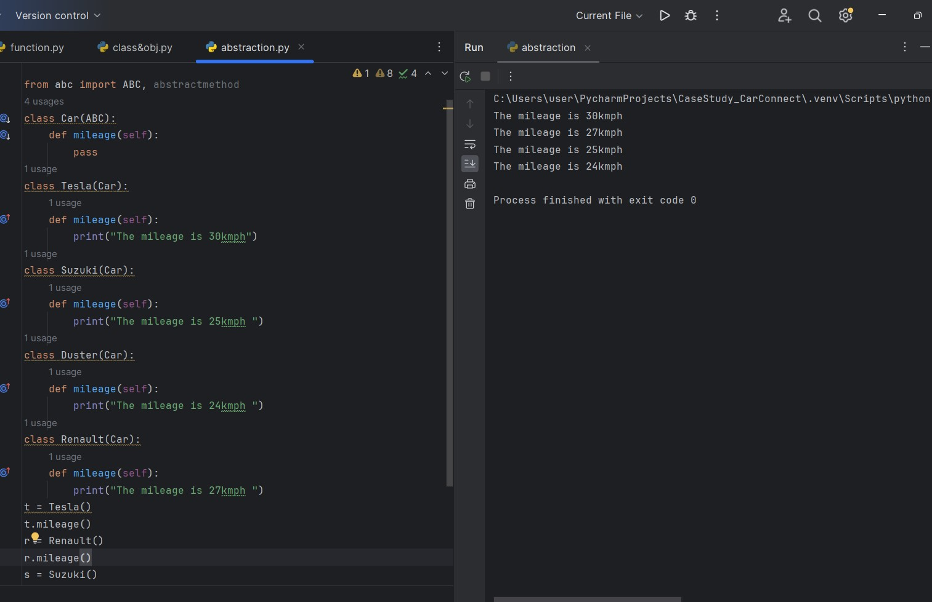

**3)Encapsulation**

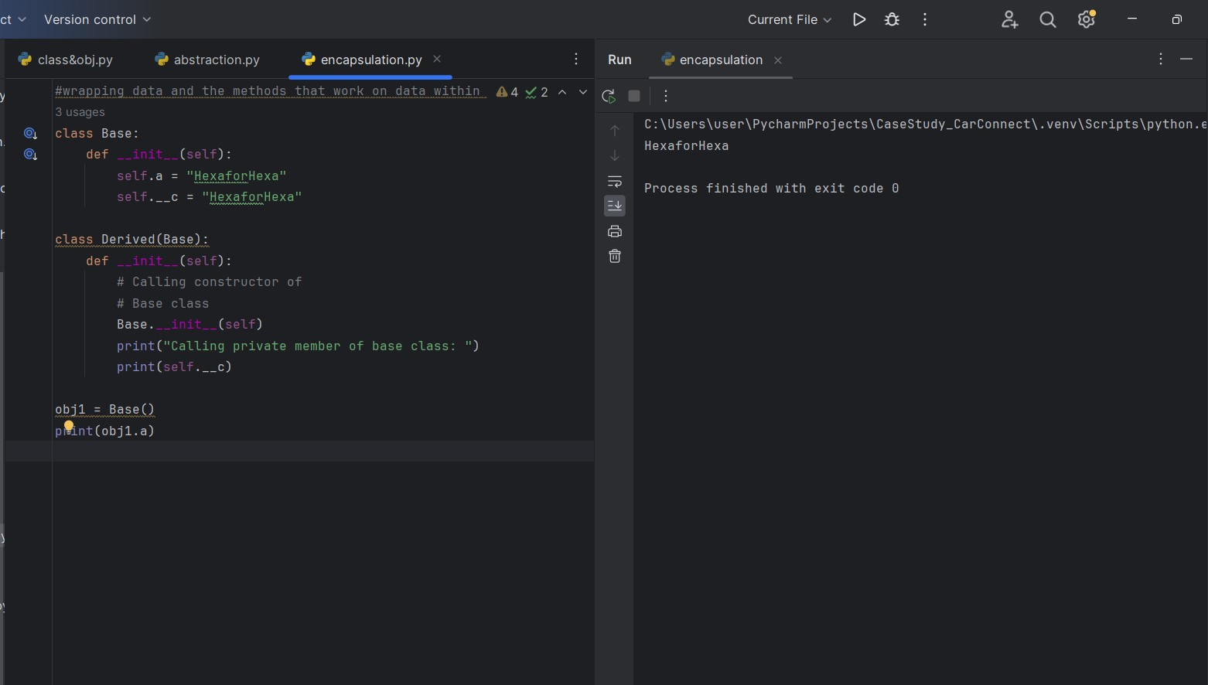

**4)Inheritance and types of inheritance**

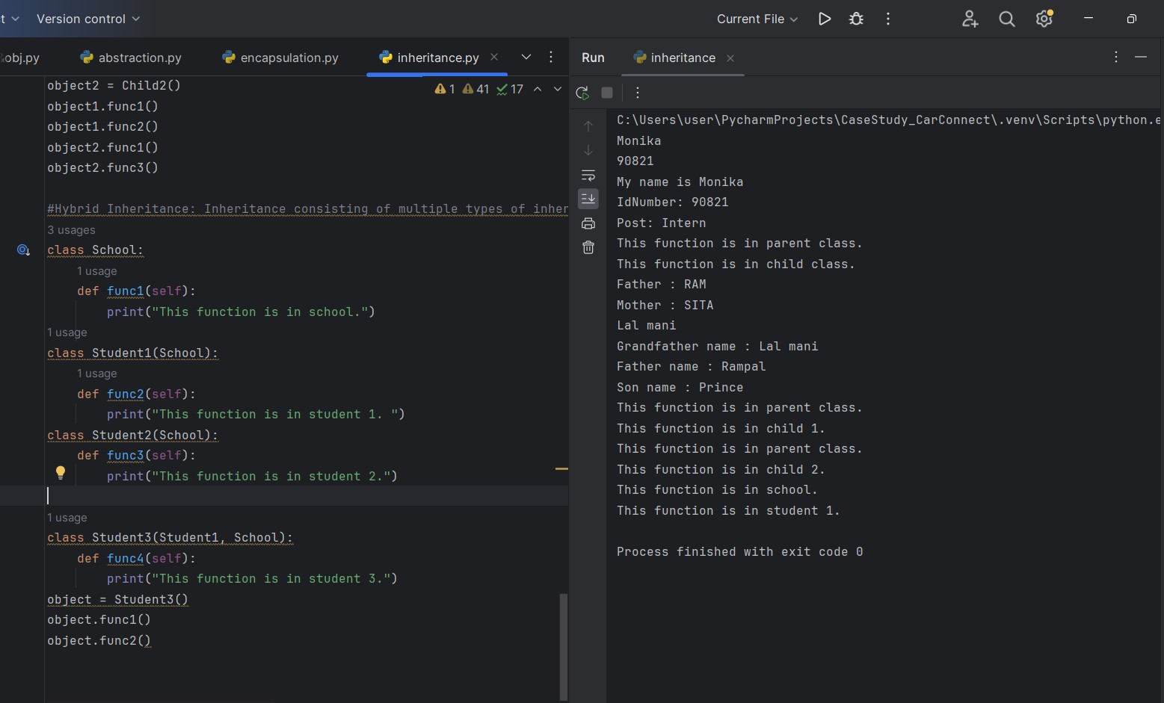

**5)Polymorphism**

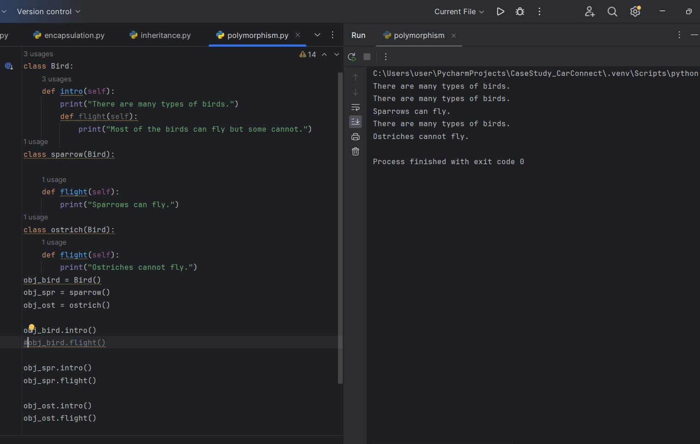

**5)Python Modules**

